JAMBOREE EMERGENCY CONTACT NUMBERS:
- Jamboree Emergency Line / Línea de Emergencia del Jamboree / Ligne d'urgence du Jamboree: (+1) 304-465-2900
- Secondary and Off-Site Emergency Line / Línea de emergencia secundaria y fuera del sitio / Ligne d'urgence secondaire et hors site: 911
- Jamboree Headquarters / Sede Central del Jamboree / Siège du Jamboree: (+1) 304-465-2800

Having trouble making a phone call? Have a staff member use the emergency radio channel.

SITE-WIDE EMERGENCIES:
In the event of a site-wide emergency, an announcement with directions will be made on our public address system, through the Jamboree app, and over staff radios. If you experience any of the following, do not wait for the announcement. Act immediately!
- Severe Weather, High Wind, and/or Lightning Alert – Seek shelter in buildings, shower houses, and large white venue tents, or under base camp pavilions.
- Tornado – Seek shelter in permanent buildings, shower houses, or low-level areas.
- Red or Black Flag Heat Advisory – Follow the water intake guide. Seek water and shade, rest, and, if needed, visit medical tents to cool off.
- Site Evacuation – Avoid or move away from the area as quickly as possible and head toward the stadium. Watch and make way for emergency vehicles.
- Base Camp Muster or Directed Headcount – If a mandatory check-in has been directed, everyone should notify their unit leader, IST work supervisor, or CMTs of their location and status. Return to your base camp and await further instructions.
- Fire -- Open fires of any kind are strictly prohibited. Only provided propane stoves are to be used for cooking. In case of fire, evacuate the area and call the Jamboree Emergency Line. If there is a fire alert, you will hear three one-second air horn blasts.

Once you have followed all official directions, stay in place until the “All Clear” message is provided.

INDIVIDUAL EMERGENCIES
Your health and wellness are the most important part of this Jamboree. Please speak with your unit leader, your IST work supervisor, or a member of the safety/medical staff if you ever feel that you need help or just want to talk about something important to you. Let us make sure we take care of each other and ourselves.
- Illness or Injury – There are medical centers in every base camp, at activity centers, and across all major areas of the Jamboree. If you feel sick or unwell, or become injured, talk to a member of our medical staff or contact the Jamboree Emergency Line. In severe medical emergencies, do not move injured persons and provide as much information as possible when calling (location, number of people, injury types, ages, etc.).
- Feeling Unsafe or Unhappy – Listening Ear and your unit leaders are here to share the weight of your feelings, worries, and thoughts. Listening Ear will have stations in each base camp and across the Jamboree. Allow us to help you.
- Safety and Security – See something, say something! Safety is everyone’s responsibility. Call the Jamboree Emergency Line to report suspicious people, unattended bags, or anything else of concern. Jamboree Stewards (security volunteers) are happy to help you and can be found on patrol, in the Trading Shops, and staffing checkpoints across the Jamboree site.
- Lost your way or your buddy? – If you feel unsafe or have become lost from others, call the Jamboree Emergency Line so that we can help you.
- Lost and Found Items -- Main Lost and Found will be open from 09:00 to 18:00 every day of the Jamboree. Scott Summit Center Lost and Found will be open from 09:00 to 18:00 each day of the Jamboree.​

THE 24TH WORLD SCOUT JAMBOREE CODE OF CONDUCT
As a participant and a Scout at the 24th World Scout Jamboree, I agree to obey all U.S., State, and local laws, as well as the following Code of Conduct:
- I am aware that I am a representative of the Scout Movement and will follow the Scout Law at all times during my travel and Jamboree participation.
- I will be respectful, tolerant, and considerate of other cultures, including dressing appropriately for a multicultural environment.
- I will obey safety rules, signs, and instructions by unit leaders and other adults.
- I will follow the Jamboree sleep schedule, unless otherwise directed by the Jamboree program, by remaining in my campsite and respecting quiet times.
- I understand that during the Jamboree the purchase, possession, or consumption of alcoholic beverages or illegal drugs is prohibited.
- I understand smoking is only permitted in marked areas and not allowed in tents. (Legal age is 18 years or older).
- I understand that gambling of any form is prohibited.
- I will avoid serious behavior issues including dishonesty, fighting, and bad language.
- I will respect other participants’ property and refrain from ‘trophy hunting’.
- I will keep the Jamboree and my personal site clean and follow recycling policies.
- I will wear my Jamboree neckerchief and Jamboree ID at all times unless to remove them for safety.
- I will comply with all elements of the Safe from Harm program to prevent abuse and harassment.
- I will only trade patches and souvenirs with my peers and will refrain from selling any items.
- I will comply with all access restrictions and will not enter private tents or sites unless invited.

SAFE FROM HARM
Scouting must always be a safe space. It is everyone’s responsibility to look out for one another and prevent harmful actions, behaviors, or words. Each individual has the right to say NO to things which make them feel uncomfortable.

It is mandatory that all adults attending the Jamboree must complete detailed training (Safe From Harm) on how to keep young people safe. If you have any concern, you should feel safe talking to your unit leader or another adult. Additionally, there will be Listening Ear IST, Medical, Safe From Harm staff, Scouts First teams, and Stewards who are trained to help resolve issues. YOU are the most important part of the Jamboree

SCOUTING FOR EVERYONE!
The World Scout Jamboree should be a place for all Scouts, regardless of physical ability, language, or other special need. The Jamboree Planning Team has worked tirelessly to provide every reasonable accommodation to ensure opportunities are available to the most Scouts possible. For personalized help, please see your local subcamp HQ or a member of the Listening Ear Team. Specific email addresses are also listed below.
- Interpretation: The official languages of the Jamboree are English, French, and Spanish. We are happy to offer additional help over the phone or in person, including in languages such as German, Arabic, Russian, Portuguese, Italian, and others. For more assistance, please email: interpretation.wsj2019@gmail.com
- Accessibility: Every program element and activity has been made as accessible as possible for those with different abilities and/or needs. Consult with your unit leader, subcamp HQ, or one of the IST at the particular program area for detailed information. For more assistance, please email: special.needs24wsj@gmail.com.
Scouts interested in learning more about the importance of including all Scouts, should visit the Transportation program area within Living in the 21st Century or the friendly Interpretation Team at the World Scout Centre.

JAMBOREE COMMUNICATIONS
To stay updated and connected to everything that is happening at the 24th World Scout Jamboree, you are invited to follow these communication sources.
- Download the Jamboree app!
- Follow us on social media! We are active on:
  - Facebook: @2019wsj
  - Instagram: @2019wsj
  - Twitter: @2019_wsj
  - Youtube: 24th World Scout Jamboree
- Use #ScoutJamboree in all your posts.
- Share the Jamboree Livestream Channel.
- Check your email daily for newsletters, announcements, and alerts.
- Find one of our many broadcast screens in high-traffic areas. These communicate general information like food menus, special programs, weather, and more.

MY BACKPACK FOR THE DAY
As you start your day, there are a number of items that you and your patrol should carry in your daypack. These are called “Safety Essentials.” These items are:
- World Jamboree ID World
- Jamboree site map
- Water bottle(s)
- Sunscreen
- Hat
- Hand sanitizer
- Lip balm with sunscreen
- Rain gear or poncho
- Personal first-aid kit
- Flashlight

Depending on your plans for the day, you may want to carry other items such as insect repellent and extra snacks. Remember, there are some items that can be shared between your patrol members, such as sunscreen or hand sanitizer. Additionally, make sure to discuss with your buddy or patrol who is bringing what before leaving. Packing all the items you need in your daypack will keep you prepared for a fun-filled day.

MY HEALTH/SAFETY REMINDERS FOR THE DAY:
- Water! ¡Agua! L’eau! Water is the most important health and safety tool you have.
- EVERYONE needs to wear sunscreen at the start of each day.
- Wash your hands often. Most diseases are spread by touching dirty hands to food, cuts, eyes, nose, and/or mouth.
- Do not approach or feed wild animals. Plants that cause rashes (Poison ivy, oak, sumac, and mountain laurel are also common and should be avoided. Contact medical if you have come into contact with any of these.
- Please note, adults and youth participants are not allowed to trade with each other. This is a Safe from Harm rule to ensure no young person owes something to another adult.

JAMBOREE APP & GRUBMASTER APP
The Official 24th World Scout Jamboree App is the most important tool you have to ensure your Best Jamboree Experience. The Jamboree App will include the latest updates, maps, schedules, and more! But it also will help you make decisions about your own day by giving you wait time estimates, distances, and activity options. For daily participant food pick up, the Grubmaster App is critical for units.

SAMPLE DAILY ITINERARIES
The following samples are only suggestions for you to plan your day. Remember, you and your friends get to decide what to experience every day. (See Below)

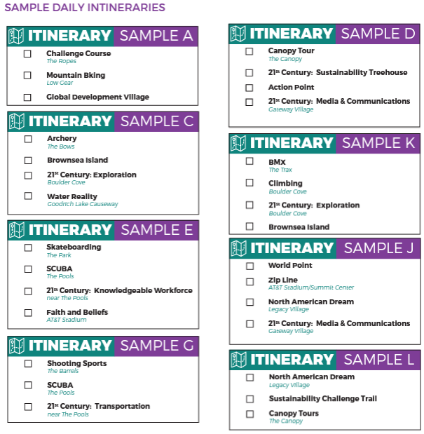

THE SUMMIT BECHTEL FAMILY NATIONAL SCOUT RESERVE
The site for the 24th World Scout Jamboree is unlike anything our Scouts have seen before. The Summit Bechtel Reserve is 10,600 acres (4,290 hectares) surrounded by wilderness that expands our Jamboree program area to 70,000 acres (28,328 hectares) -- larger than some entire countries! From Scott Summit Center to the New River Gorge National River, this Jamboree will be filled with wild fun and will be your home for an adventure of a lifetime. We are so excited to share this special place with you.
- Longest combined zip lines in the world (5.45 miles, 8.7 kilometers)
- Longest canopy course in the country (9.55 miles, 15.3 kilometers)
- Largest man-made outdoor climbing facility in the country (218 stations)
- Second-largest outdoor skatepark in the country (4.6 acres, 1.7 hectares)
- Second-largest BMX facility in the country (13.7 acres, 5.3 hectares)
- Third-largest combined rifle, shotgun, and pistol shooting venue in the country
- Third-largest archery range in the country (116 stations)
- Largest natural outdoor arena in West Virginia (80,000 people capacity)

WHAT CAN VISITORS SEE?
Visitors are able to move freely through the 100 acres (40.5 hectares) of Scott Summit Center, stretching from the CONSOL Energy Bridge to the Goodrich Lake dam. This area is the heart of the Jamboree and includes rich programming, engaging exhibits, and opportunities for cultural exchanges.

In this area, visitors have full access to the Global Development Village, the Sustainability Treehouse, World Scout Center, International Food Houses (food for purchase), and Centro Mondial. They will also be able to see the exciting adventure programs of Action Point, trade items with those of the same age group, and can participate in guided tours. Helpful information booths can help make these opportunities clear and available. Don't forget to stop by the Jamboree Trading Shops, which offer apparel, souvenirs, flags, emblems, name plates, electronics, camp equipment, bags, and much more. Gateway Trading Shop --- Working Hours: 08:00 to 18:00 --- Working Days: July 22 to August 1st

While there will be plenty for day visitors to do, adventure programs such as aerial sports, climbing walls, skate parks, biking, are reserved for Jamboree participants. Guests will not be able to visit base camps, Scout living areas, or adventure zone areas. This is strictly enforced. Please follow the directions of security staff.

BASE CAMPS AND SUBCAMPS

AGRA FORT
Subcamp A1 – Acropolis
Subcamp A2 – Angkor
Subcamp A3 – Aksum
Subcamp A4 – Anjar

BLENHEIM PALACE
Subcamp B1 – Brazilia
Subcamp B2 – Butrint
Subcamp B3 – Boyana Church
Subcamp B4 – Byblos

CANADIAN ROCKIES
Subcamp C1 – Canterbury Cathedral
Subcamp C2 – Centennial Hall
Subcamp C3 – Carlsbad Caverns
Subcamp C4 – Castel del Monte

DURHAM CASTLE
Subcamp D1 – Delos
Subcamp D2 – Darien National Park
Subcamp D3 – Danube Delta
Subcamp D4 – Dinosaur Provincial Park

EPHESUS
Subcamp E1 – Everglades
Subcamp E2 – Ellora
Subcamp E3 – Ennedi
Subcamp E4 – El Tajin

FORT JESUS
Subcamp F1 – Fraser Island
Subcamp F2 – Fortress of Suomenlinna

INTERNATIONAL FOOD HOUSE OPTIONS
The International Food Houses are a major attraction of every Jamboree. Eleven countries from around the world will gather in Action Point to provide the tastes, aromas, culture, and camaraderie of their homelands with all of you. The hours of operations for these food houses are between 08:00 to 22:00 daily. Some international food houses also host special activities and events. Check with your favorite food house to find out more.

Countries that are hosting a food house include: Brazil, Canada, Chile, Colombia, Germany, Italy, Netherlands, Portugal, United Kingdom, and the United States.

DISTANCES AND TIMES
How long will it take me to get there? Check this table which lists walking times for all major destinations. Simply find your current location on the left and your destination on the top. The look at the box where these two locations meet, which notes the number of minutes it will take you to get there.

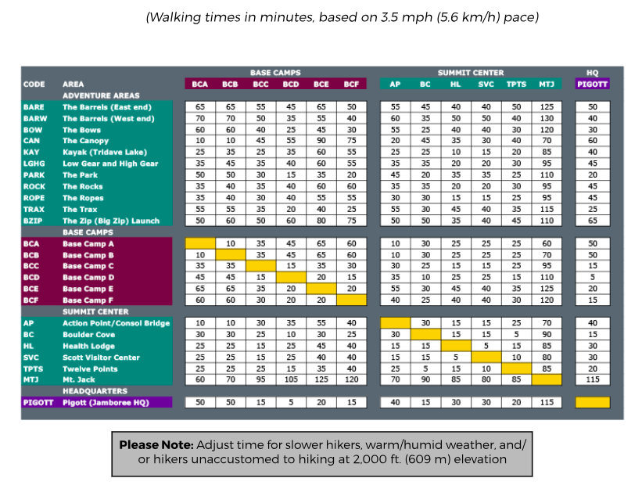

PROGRAM
When deciding where to go, make sure to explore all of the different program areas that the Jamboree has! There are adventure activities, exhibit tents, interactive expositions, and exciting multicultural communities to explore. See and enjoy them all!

Centro Mondial
North American Dream
​Faith and Beliefs
​Living in the 21st Century
​Knowledgeable Workforce
​Exploration
​Communications and Media
​ Transportation
​History of Scouting (Brownsea Island)

World Point
World Scout Centre
​Friendship Hub
​Festival of Nations
​Spirit of Adventure
​
Scouts for Sustainable Development Goals
​WOSM – Better World Tent
​Global Development Village

Adventure Programs
​Aerial Sports
​ Big Zip
​ The Canopy
​ The Ropes
​ Gateway and Legacy Zip
​Aquatics
​ Kayak
​ Standup Paddleboarding (SUP)
​ Team Standup Paddleboarding (SUP)
​ SCUBA
​ Water Reality
​Climbing
​ The Rocks
​ Boulder Cove
Extreme Sports
​ Low Gear
​ High Gear
​ The Park
​ The Trax
River Experience
​ River Rafting
​Shooting Sports
​ The Barrels – East
​ The Barrels – West
​ The Bows
​ Joe Crafton Sportsman’s Hall
​Action Point Adventure Area
​ Action Point – Canopy
​ Action Point – Mountain Biking
​ Action Point – Skateboard
​ Action Point – BMX

